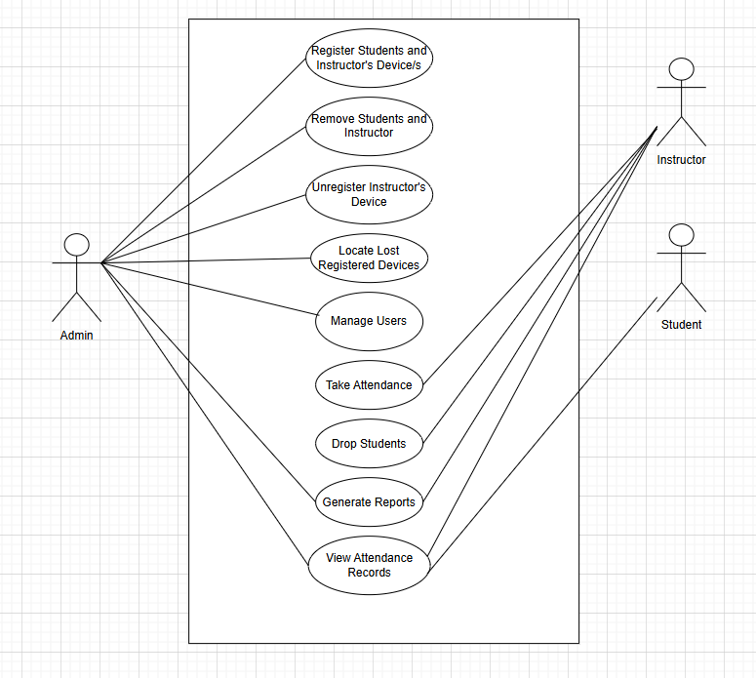HIGH LEVEL USE CASE DIAGRAM